MAYHEM II
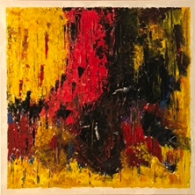
ACRYLIC ON CANVAS, 20X20X1.2”, WIRED AND READY TO HANG.
A BOLD COLLECTION OF BRIGHT COLORS IN A DRAMATIC ARRAY. IF THIS WERE MUSIC IT WOULD RELATE TO SOME LOUD ROCK.
$350, SHIPPING NOT INCLUDED.
CALL OR TEXT (314) 630-9761

